Support for Polio Eradication Activities
In CHAD
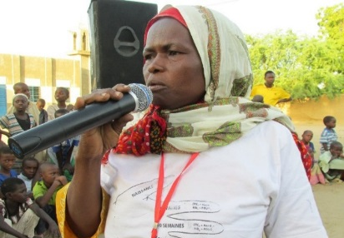
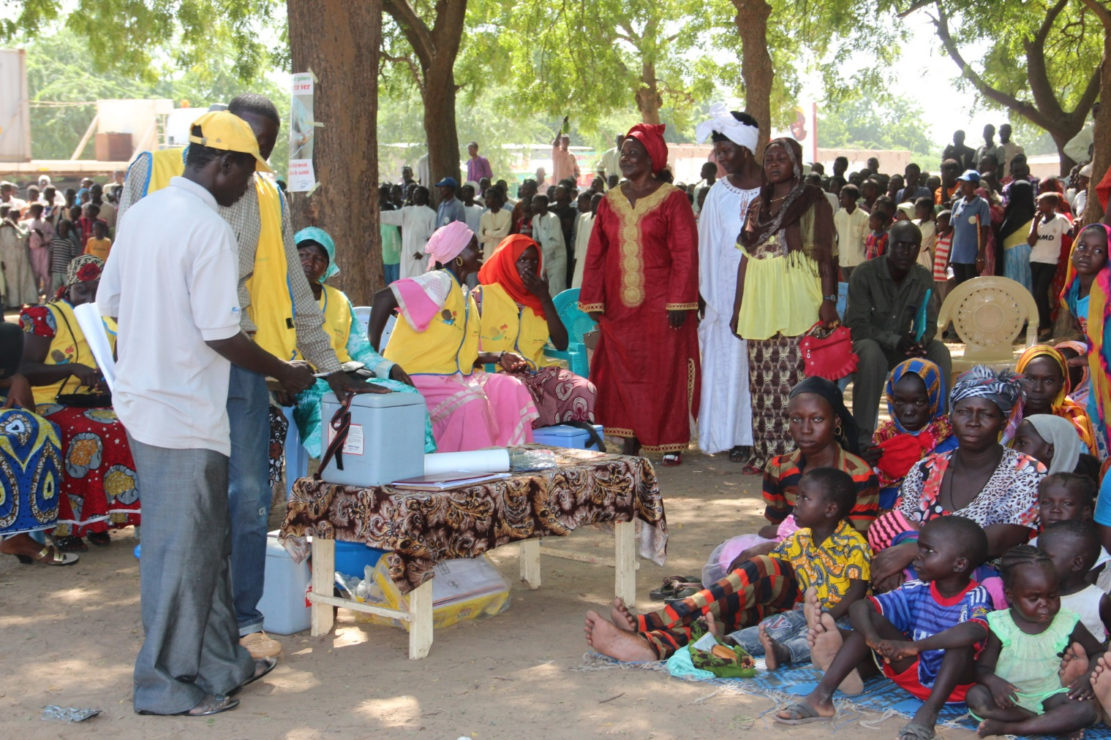
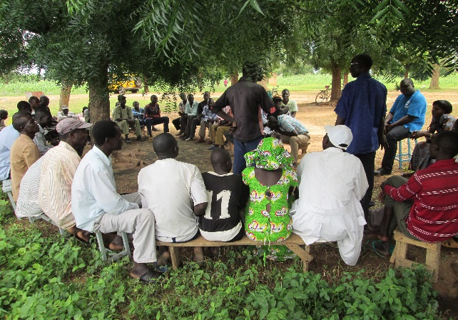
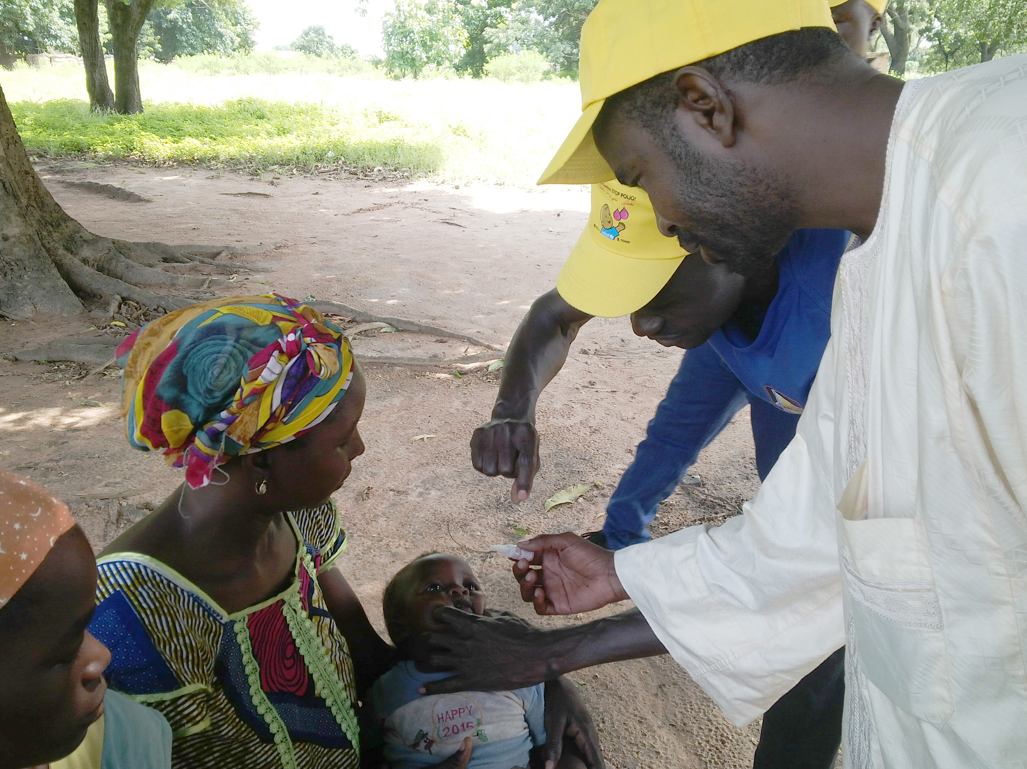
IPPC JANUARY 2016
UNICEF – CHAD

Polio Eradication in Chad
  - COUNTRY UPDATE
1.1.1 Brief Introduction
Following the confirmation of 132 cases of wild poliovirus (WPV) in 2011 and 5 cases in 2012, as well as 12 cases of vaccine-derived polio virus (cVDPV) in late June 2013, WHO and UNICEF increased the number of field staff, which has contributed to a better utilization of resources and improvement of immunization activities and data reporting. Several polio immunization campaigns have been conducted over the last few years in order to eradicate polio in Chad. In addition to immunization activities, high levels of political commitment, including monthly immunization meetings chaired by the Head of State, and community engagement were necessary to control the outbreak. Thanks to these efforts, tangible results have been registered, and no cases of WPV have been reported since June 2012.
The risk of re-importation of the poliovirus remains high in Chad. In Nigeria and Cameroon, two countries bordering Chad, WPV cases were reported in 2014. No cases of WPV were reported in both countries in the last 12 months. However, the threat of re-importation of the virus persists because of the porosity of the borders between Chad and the neighboring countries, and the movement of populations, including nomadic and refugee groups fleeing the armed conflict perpetrated by Boko Haram. An additional immunization-related challenge is presented by the fact that Chad’s southern neighbor, Central African Republic (CAR), plagued by armed conflict in 2013-2015, has sent to Chad more than 100,000 returnees, refugees and Third Country Nationals (TCN), most with an unknown vaccination status. The weak Chadian immunization system and low immunization coverage cannot guarantee a polio-free future in Chad. Therefore, the country must remain on high alert. Building on the existing polio infrastructure and human resources, efforts must be made to strengthen routine immunization, increase the routine immunization coverage and improve immunity among the Chadian population.
1.1.2 Progress to Date (since the last IPPC June 2015).
Epidemiology: The last case of wild poliovirus was confirmed in the region of Lake Chad in June 2012 (WPV-1), and the last case of cVDPV was registered in May 2013.

Table 1: Number of cases/outbreaks by region (2011-2015)
Weekly follow-up of wild polio virus by region between 2011 and 2015

Health regions |  | Years |  |  |  |  |  |  |  |  |  |  |  |  |  |  |  |  |  |  |  |  |  |  |  |  |  |  |  |  |  |  |  |  |  |  |  |  |  |  |  |  |  |  |  |  |  |  |  |  |  |  |  |  |  |  |  |  |  |  |  |  |  | Date  Onset of the last case
 |  | 2011 |  |  |  |  |  |  |  |  |  |  |  | 2012 |  |  |  |  |  |  |  |  |  |  |  |  | 2013 |  |  |  |  |  |  |  |  |  |  |  |  | 2014 |  |  |  |  |  |  |  |  |  |  |  |  | 2015
 | J |  | F | M | A | M | J | J | A | S | O | N | D |  | J | F | M | A | M | J | J | A | S | O | N | D |  | J | F | M | A | M | J | J | A | S | O | N | D |  | J | F | M | A | M | J | J | A | S | O | N | D |  | J | F | M | A | M | J | J | A | S | O
Ennedi Est | 0 |  | 0 | 0 | 0 | 0 | 0 | 0 | 0 | 0 | 0 | 0 | 0 |  | 0 | 0 | 0 | 0 | 0 | 0 | 0 | 0 | 0 | 0 | 0 | 0 |  | 0 | 0 | 0 | 0 | 0 | 0 | 0 | 0 | 0 | 0 | 0 | 0 |  | 0 | 0 | 0 | 0 | 0 | 0 | 0 | 0 | 0 | 0 | 0 | 0 |  | 0 | 0 | 0 | 0 | 0 | 0 | 0 | 0 | 0 | 0 |  | NA
Ennedi Ouest | 0 |  | 0 | 0 | 0 | 0 | 0 | 0 | 0 | 0 | 0 | 0 | 0 |  | 0 | 0 | 0 | 0 | 0 | 0 | 0 | 0 | 0 | 0 | 0 | 0 |  | 0 | 0 | 0 | 0 | 0 | 0 | 0 | 0 | 0 | 0 | 0 | 0 |  | 0 | 0 | 0 | 0 | 0 | 0 | 0 | 0 | 0 | 0 | 0 | 0 |  | 0 | 0 | 0 | 0 | 0 | 0 | 0 | 0 | 0 | 0 |  | NA
Hadjar Lamis | 0 |  | 0 | 0 | 0 | 0 | 0 | 0 | 0 | 0 | 0 | 0 | 0 |  | 0 | 0 | 0 | 0 | 0 | 0 | 0 | 0 | 0 | 0 | 0 | 0 |  | 0 | 0 | 0 | 0 | 0 | 0 | 0 | 0 | 0 | 0 | 0 | 0 |  | 0 | 0 | 0 | 0 | 0 | 0 | 0 | 0 | 0 | 0 | 0 | 0 |  | 0 | 0 | 0 | 0 | 0 | 0 | 0 | 0 | 0 | 0 |  | NA
Borkou | 0 |  | 0 | 0 | 0 | 0 | 0 | 0 | 0 | 0 | 0 | 0 | 0 |  | 0 | 0 | 0 | 0 | 0 | 0 | 0 | 0 | 0 | 0 | 0 | 0 |  | 0 | 0 | 0 | 0 | 0 | 0 | 0 | 0 | 0 | 0 | 0 | 0 |  | 0 | 0 | 0 | 0 | 0 | 0 | 0 | 0 | 0 | 0 | 0 | 0 |  | 0 | 0 | 0 | 0 | 0 | 0 | 0 | 0 | 0 | 0 |  | NA
Tibesti | 0 |  | 0 | 0 | 0 | 0 | 0 | 0 | 0 | 0 | 0 | 0 | 0 |  | 0 | 0 | 0 | 0 | 0 | 0 | 0 | 0 | 0 | 0 | 0 | 0 |  | 0 | 0 | 0 | 0 | 0 | 0 | 0 | 0 | 0 | 0 | 0 | 0 |  | 0 | 0 | 0 | 0 | 0 | 0 | 0 | 0 | 0 | 0 | 0 | 0 |  | 0 | 0 | 0 | 0 | 0 | 0 | 0 | 0 | 0 | 0 |  | NA
Kanem | 0 |  | 0 | 1 | 0 | 0 | 0 | 0 | 0 | 0 | 0 | 0 | 0 |  | 0 | 0 | 0 | 0 | 0 | 0 | 0 | 0 | 0 | 0 | 0 | 0 |  | 0 | 0 | 0 | 0 | 0 | 0 | 0 | 0 | 0 | 0 | 0 | 0 |  | 0 | 0 | 0 | 0 | 0 | 0 | 0 | 0 | 0 | 0 | 0 | 0 |  | 0 | 0 | 0 | 0 | 0 | 0 | 0 | 0 | 0 | 0 |  | 08/03/2011
Mayo Kebbi Ouest | 0 |  | 0 | 0 | 1 | 1 | 0 | 0 | 0 | 0 | 0 | 0 | 0 |  | 0 | 0 | 0 | 0 | 0 | 0 | 0 | 0 | 0 | 0 | 0 | 0 |  | 0 | 0 | 0 | 0 | 0 | 0 | 0 | 0 | 0 | 0 | 0 | 0 |  | 0 | 0 | 0 | 0 | 0 | 0 | 0 | 0 | 0 | 0 | 0 | 0 |  | 0 | 0 | 0 | 0 | 0 | 0 | 0 | 0 | 0 | 0 |  | 20/05/2011
Dar Sila | 1 |  | 1 | 1 | 0 | 2 | 1 | 1 | 0 | 0 | 0 | 0 | 0 |  | 0 | 0 | 0 | 0 | 0 | 0 | 0 | 0 | 0 | 0 | 0 | 0 |  | 0 | 0 | 0 | 0 | 0 | 0 | 0 | 0 | 0 | 0 | 0 | 0 |  | 0 | 0 | 0 | 0 | 0 | 0 | 0 | 0 | 0 | 0 | 0 | 0 |  | 0 | 0 | 0 | 0 | 0 | 0 | 0 | 0 | 0 | 0 |  | 14/07/2011
Logone Occidental | 0 |  | 2 | 3 | 3 | 6 | 0 | 1 | 0 | 0 | 0 | 0 | 0 |  | 0 | 0 | 0 | 0 | 0 | 0 | 0 | 0 | 0 | 0 | 0 | 0 |  | 0 | 0 | 0 | 0 | 0 | 0 | 0 | 0 | 0 | 0 | 0 | 0 |  | 0 | 0 | 0 | 0 | 0 | 0 | 0 | 0 | 0 | 0 | 0 | 0 |  | 0 | 0 | 0 | 0 | 0 | 0 | 0 | 0 | 0 | 0 |  | 16/07/2011
Salamat | 0 |  | 0 | 1 | 1 | 2 | 1 | 3 | 0 | 0 | 0 | 0 | 0 |  | 0 | 0 | 0 | 0 | 0 | 0 | 0 | 0 | 0 | 0 | 0 | 0 |  | 0 | 0 | 0 | 0 | 0 | 0 | 0 | 0 | 0 | 0 | 0 | 0 |  | 0 | 0 | 0 | 0 | 0 | 0 | 0 | 0 | 0 | 0 | 0 | 0 |  | 0 | 0 | 0 | 0 | 0 | 0 | 0 | 0 | 0 | 0 |  | 22/07/2011
Wadi Fira | 2 |  | 1 | 0 | 3 | 0 | 0 | 2 | 0 | 0 | 0 | 0 | 0 |  | 0 | 0 | 0 | 0 | 0 | 0 | 0 | 0 | 0 | 0 | 0 | 0 |  | 0 | 0 | 0 | 0 | 0 | 0 | 0 | 0 | 0 | 0 | 0 | 0 |  | 0 | 0 | 0 | 0 | 0 | 0 | 0 | 0 | 0 | 0 | 0 | 0 |  | 0 | 0 | 0 | 0 | 0 | 0 | 0 | 0 | 0 | 0 |  | 22/07/2011
Mandoul | 0 |  | 0 | 0 | 0 | 0 | 0 | 2 | 0 | 0 | 0 | 0 | 0 |  | 0 | 0 | 0 | 0 | 0 | 0 | 0 | 0 | 0 | 0 | 0 | 0 |  | 0 | 0 | 0 | 0 | 0 | 0 | 0 | 0 | 0 | 0 | 0 | 0 |  | 0 | 0 | 0 | 0 | 0 | 0 | 0 | 0 | 0 | 0 | 0 | 0 |  | 0 | 0 | 0 | 0 | 0 | 0 | 0 | 0 | 0 | 0 |  | 31/07/2011
Ouaddai | 0 |  | 1 | 0 | 0 | 0 | 1 | 0 | 1 | 0 | 0 | 0 | 0 |  | 0 | 0 | 0 | 0 | 0 | 0 | 0 | 0 | 0 | 0 | 0 | 0 |  | 0 | 0 | 0 | 0 | 0 | 0 | 0 | 0 | 0 | 0 | 0 | 0 |  | 0 | 0 | 0 | 0 | 0 | 0 | 0 | 0 | 0 | 0 | 0 | 0 |  | 0 | 0 | 0 | 0 | 0 | 0 | 0 | 0 | 0 | 0 |  | 10/08/2011
N'Djamena | 0 |  | 0 | 0 | 0 | 0 | 0 | 0 | 0 | 1 | 0 | 0 | 0 |  | 0 | 0 | 0 | 0 | 0 | 0 | 0 | 0 | 0 | 0 | 0 | 0 |  | 0 | 0 | 0 | 0 | 0 | 0 | 0 | 0 | 0 | 0 | 0 | 0 |  | 0 | 0 | 0 | 0 | 0 | 0 | 0 | 0 | 0 | 0 | 0 | 0 |  | 0 | 0 | 0 | 0 | 0 | 0 | 0 | 0 | 0 | 0 |  | 03/09/2011
Batha | 0 |  | 0 | 1 | 1 | 2 | 0 | 0 | 0 | 1 | 1 | 0 | 0 |  | 0 | 0 | 0 | 0 | 0 | 0 | 0 | 0 | 0 | 0 | 0 | 0 |  | 0 | 0 | 0 | 0 | 0 | 0 | 0 | 0 | 0 | 0 | 0 | 0 |  | 0 | 0 | 0 | 0 | 0 | 0 | 0 | 0 | 0 | 0 | 0 | 0 |  | 0 | 0 | 0 | 0 | 0 | 0 | 0 | 0 | 0 | 0 |  | 05/10/2011
Bahr El gazal | 0 |  | 0 | 0 | 0 | 0 | 0 | 0 | 0 | 0 | 1 | 0 | 0 |  | 0 | 0 | 0 | 0 | 0 | 0 | 0 | 0 | 0 | 0 | 0 | 0 |  | 0 | 0 | 0 | 0 | 0 | 0 | 0 | 0 | 0 | 0 | 0 | 0 |  | 0 | 0 | 0 | 0 | 0 | 0 | 0 | 0 | 0 | 0 | 0 | 0 |  | 0 | 0 | 0 | 0 | 0 | 0 | 0 | 0 | 0 | 0 |  | 20/10/2011
Moyen Chari | 0 |  | 0 | 0 | 1 | 1 | 3 | 1 | 0 | 0 | 1 | 0 | 0 |  | 0 | 0 | 0 | 0 | 0 | 0 | 0 | 0 | 0 | 0 | 0 | 0 |  | 0 | 0 | 0 | 0 | 0 | 0 | 0 | 0 | 0 | 0 | 0 | 0 |  | 0 | 0 | 0 | 0 | 0 | 0 | 0 | 0 | 0 | 0 | 0 | 0 |  | 0 | 0 | 0 | 0 | 0 | 0 | 0 | 0 | 0 | 0 |  | 27/10/2011
Tandjile | 0 |  | 0 | 0 | 1 | 0 | 2 | 1 | 1 | 1 | 0 | 1 | 0 |  | 0 | 0 | 0 | 0 | 0 | 0 | 0 | 0 | 0 | 0 | 0 | 0 |  | 0 | 0 | 0 | 0 | 0 | 0 | 0 | 0 | 0 | 0 | 0 | 0 |  | 0 | 0 | 0 | 0 | 0 | 0 | 0 | 0 | 0 | 0 | 0 | 0 |  | 0 | 0 | 0 | 0 | 0 | 0 | 0 | 0 | 0 | 0 |  | 05/11/2011
Guera | 0 |  | 0 | 0 | 0 | 1 | 0 | 2 | 0 | 1 | 0 | 1 | 0 |  | 0 | 0 | 0 | 0 | 0 | 0 | 0 | 0 | 0 | 0 | 0 | 0 |  | 0 | 0 | 0 | 0 | 0 | 0 | 0 | 0 | 0 | 0 | 0 | 0 |  | 0 | 0 | 0 | 0 | 0 | 0 | 0 | 0 | 0 | 0 | 0 | 0 |  | 0 | 0 | 0 | 0 | 0 | 0 | 0 | 0 | 0 | 0 |  | 19/11/2011
Mayo Kebbi Est | 0 |  | 0 | 0 | 0 | 0 | 0 | 0 | 0 | 0 | 0 | 0 | 1 |  | 0 | 0 | 0 | 0 | 0 | 0 | 0 | 0 | 0 | 0 | 0 | 0 |  | 0 | 0 | 0 | 0 | 0 | 0 | 0 | 0 | 0 | 0 | 0 | 0 |  | 0 | 0 | 0 | 0 | 0 | 0 | 0 | 0 | 0 | 0 | 0 | 0 |  | 0 | 0 | 0 | 0 | 0 | 0 | 0 | 0 | 0 | 0 |  | 20/12/2011
Logone Oriental | 11 |  | 2 | 8 | 15 | 9 | 2 | 3 | 0 | 0 | 6 | 2 | 0 |  | 1 | 1 | 0 | 0 | 0 | 0 | 0 | 0 | 0 | 0 | 0 | 0 |  | 0 | 0 | 0 | 0 | 0 | 0 | 0 | 0 | 0 | 0 | 0 | 0 |  | 0 | 0 | 0 | 0 | 0 | 0 | 0 | 0 | 0 | 0 | 0 | 0 |  | 0 | 0 | 0 | 0 | 0 | 0 | 0 | 0 | 0 | 0 |  | 19/02/2012
Chari Baguirmi | 0 |  | 0 | 0 | 0 | 0 | 0 | 0 | 0 | 0 | 0 | 0 | 0 |  | 0 | 1 | 0 | 0 | 0 | 0 | 0 | 0 | 0 | 0 | 0 | 0 |  | 0 | 0 | 0 | 0 | 0 | 0 | 0 | 0 | 0 | 0 | 0 | 0 |  | 0 | 0 | 0 | 0 | 0 | 0 | 0 | 0 | 0 | 0 | 0 | 0 |  | 0 | 0 | 0 | 0 | 0 | 0 | 0 | 0 | 0 | 0 |  | 21/02/2012
Lac | 0 |  | 0 | 0 | 0 | 0 | 0 | 0 | 0 | 0 | 0 | 0 | 0 |  | 0 | 0 | 0 | 1 | 0 | 1 | 0 | 0 | 0 | 0 | 0 | 0 |  | 0 | 0 | 0 | 0 | 0 | 0 | 0 | 0 | 0 | 0 | 0 | 0 |  | 0 | 0 | 0 | 0 | 0 | 0 | 0 | 0 | 0 | 0 | 0 | 0 |  | 0 | 0 | 0 | 0 | 0 | 0 | 0 | 0 | 0 | 0 |  | 14/06/2012
TOTAL COUNTRY | 14 |  | 7 | 15 | 26 | 24 | 10 | 16 | 2 | 4 | 9 | 4 | 1 |  | 1 | 2 | 0 | 1 | 0 | 1 | 0 | 0 | 0 | 0 | 0 | 0 |  | 0 | 0 | 0 | 0 | 0 | 0 | 0 | 0 | 0 | 0 | 0 | 0 |  | 0 | 0 | 0 | 0 | 0 | 0 | 0 | 0 | 0 | 0 | 0 | 0 |  | 0 | 0 | 0 | 0 | 0 | 0 | 0 | 0 | 0 | 0
Source: WHO/Chad, Feb. 2015

- Surveillance/lab update.
Table 2: Number of AFP cases by region (2014-2015)
Health regions | Week 1-43/2014  AFP surveillance |  |  |  |  | Week 1-43/2015
Health regions | AFP case | AFP case with T°<= 8°c | Non Polio rate | % AFP with 2 stoolls within 14 days | % Non Polio enterovirus | AFP case | AFP case with T°<= 8°c | Non Polio rate | % AFP with 2 stoolls within 14 days | % Non Polio enterovirus
Barh-Elgazal | 9 | 6 | 7,04 | 78 | 22,2 | 11 | 5 | 8,32 | 82 | 14,3
Batha | 11 | 8 | 4,53 | 91 | 27,3 | 6 | 6 | 2,39 | 83 | 16,7
Borkou | 0 | NA | 0,00 | NA | NA | 2 | 2 | 4,16 | 50 | 0,0
Chari-Baguirmi | 18 | 15 | 5,91 | 89 | 17,6 | 14 | 12 | 4,71 | 100 | 0,0
Dar Sila | 10 | 6 | 5,19 | 90 | 40,0 | 9 | 9 | 4,52 | 89 | 12,5
Ennedi Est | 1 | 0 | 1,88 | 100 | 100,0 | 1 | 0 | 1,81 | 100 | 100,0
Ennedi Ouest | 2 | 1 | 6,64 | 100 | 0,0 | 4 | 4 | 12,84 | 75 | 0,0
Guera | 19 | 15 | 6,73 | 95 | 12,5 | 16 | 15 | 5,78 | 94 | 0,0
Hadjer Lamis | 9 | 9 | 3,19 | 78 | 0,0 | 16 | 15 | 5,49 | 100 | 20,0
Kanem | 8 | 4 | 4,83 | 100 | 0,0 | 6 | 5 | 3,50 | 83 | 0,0
Lac | 11 | 8 | 5,10 | 100 | 18,2 | 18 | 16 | 8,08 | 94 | 6,3
Logone Occidental | 22 | 18 | 6,42 | 95 | 9,5 | 15 | 13 | 4,24 | 93 | 16,7
Logone Oriental | 29 | 25 | 7,49 | 100 | 3,6 | 26 | 24 | 6,49 | 96 | 13,0
Mandoul | 21 | 13 | 6,73 | 95 | 20,0 | 31 | 30 | 9,61 | 87 | 10,7
Mayo-Kebbi-Est | 19 | 18 | 4,93 | 95 | 22,2 | 20 | 15 | 5,02 | 100 | 20,0
Mayo-Kebbi-Ouest | 13 | 10 | 4,63 | 100 | 9,1 | 24 | 22 | 8,27 | 100 | 21,7
Moyen-Chari | 27 | 15 | 9,24 | 96 | 15,4 | 25 | 23 | 8,27 | 96 | 4,3
N'Djaména | 47 | 43 | 9,73 | 98 | 21,3 | 27 | 26 | 5,52 | 100 | 20,0
Ouaddai | 16 | 10 | 4,19 | 88 | 33,3 | 29 | 27 | 7,83 | 93 | 16,7
Salamat | 10 | 9 | 5,99 | 100 | 11,1 | 7 | 4 | 3,86 | 86 | 0,0
Tandjilé | 14 | 8 | 4,26 | 86 | 7,7 | 16 | 14 | 4,70 | 100 | 13,3
Tibesti | 0 | NA | 0,00 | NA | NA | 1 | 0 | 0,00 | 100 | 0,0
Wadi Fira | 13 | 9 | 5,15 | 92 | 0,0 | 13 | 13 | 4,59 | 100 | 16,7
TOTAL | 329 | 250 | 5,91 | 94 | 16,0 | 337 | 300 | 5,89 | 94 | 12,7
Source: WHO/Chad, Feb. 2015
TAG meeting recommendations: The 11th TAG meeting held in N’Djamena in May 2015 recommended that all silent zones should be identified. In addition, we must enhance Active Flaccid Paralysis (AFP) surveillance through active surveillance visits and supervision, including the active search for AFP cases during and between Supplementary Immunization Activities (SIAs), until the certification of the African region is reached. This recommendation was implemented and as a result, as shown in the table above, 19 out of 23 regions have met two major indicators of monitoring in 2015, compared to 18 in 2014. Zero regions were silent in 2015, compared to two silent regions in 2014 (Bourkou and Tibesti). Regarding samples transportation, 300 out of 337 cases (89%) arrived at the central level with a suitable temperature in 2015, compared to 250 out of 329 cases (76%) in 2014. Polio environmental surveillance was carried out. 28 samples were collected and sent to the Pasteur Center in Yaoundé, 24 were confirmed negative and the status of 4 are still pending.
sNIDs/NIDs
Figure 1: Polio Supplementary Immunization Activities and Wild Poliovirus outbreaks per region (2010-2015)
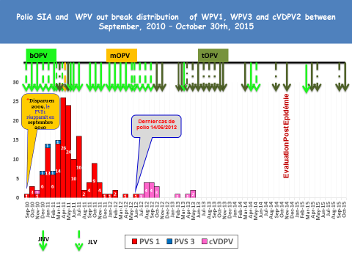
Source: WHO/Chad, Feb. 2015
In Chad, 21 polio campaigns were carried out between 2013 and 2015. Four National Immunization Days targeting 4 millions of under-five children per round and two Sub-National Immunization Days targeting 1.9 million under-five children were planned and conducted in 2015 respectively in March, April, May, September, October and November. The administrative coverage reached almost 100% during each campaign. Data collected during these campaigns shows that the number of parents aware of the campaign increased while the number of refusals decreased.

Communication and Social Mobilization
Our 2016 communication and social mobilization strategy involves maintaining a scaled-up level of human resources to allow for capacity strengthening of national partners to improve their interpersonal communication skills to influence both the supply (health agent) and demand (community member) sides of vaccination promotion. The strategy combines strengthened interpersonal communication and mass media messages (SMS blasts, community radio, theater, etc.) to raise parent awareness during campaigns and promote routine immunization. Advocacy efforts will be made to maintain the strong existing levels of political and opinion-leader engagement in support of immunization. As shown on the graphs below, parent awareness increased between 2014 and 2015, thus reducing the proportion of missed children during the campaigns. By September 2015, the proportion of missed children due to refusal was reduced to 4%.
UNICEF supported the Ministry of health in developing an integrated strategic communication plan for EPI for the period 2016-2018. This plan includes strategies to improve the demand for routine immunization, as well as special strategies for Polio eradication, reaching hard-to-reach populations, including nomadic groups, and introducing new vaccines.
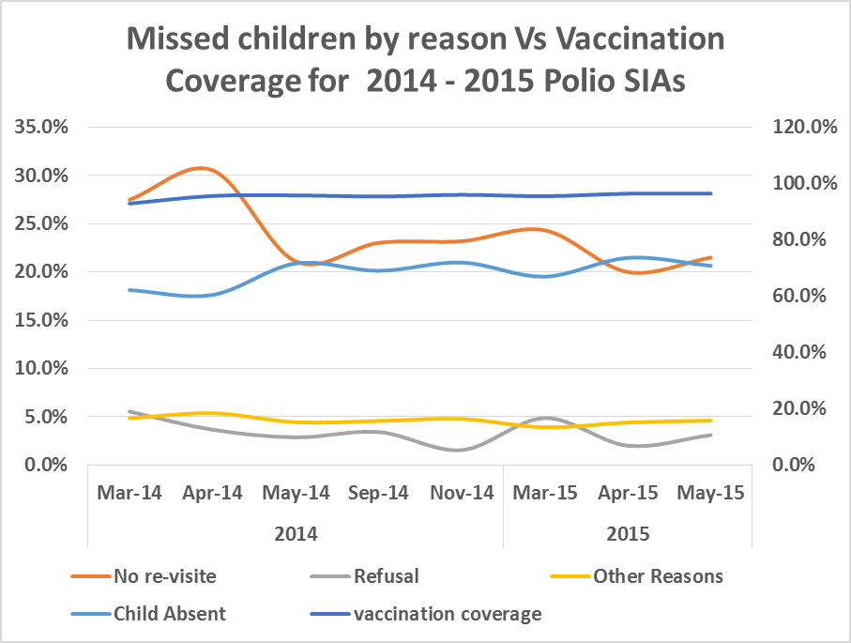

A community based approach for improving the demand for immunization services will be implemented in 15 high risk districts in 2016 and scaled up in 2017.
Outreach activities will continue through ongoing partnerships with national and community radio stations and Community Based Organizations (CBOs) in order to increase the demand for vaccination among the hard-to-reach populations (nomads, island dwellers, etc.). In addition, communication strategies will be implemented to support the progressive IPV rollout in the beginning of the year, and the switch from the tOPV to the bOPV.
The priority areas for 2016 are the districts at high risk of re-importation from neighboring countries (Niger, Nigeria, Cameroon and Central African Republic), as shown in the map in Annex I..
Challenges
- Prevent importation of WPV from neighboring countries through intensified efforts to sensitize and immunize hard-to-reach populations (insular, mobile/nomad, and returnee/refugee populations).
- Maintain quality of routine immunization activities despite back-to-back campaigns (polio, tetanus).
- Increase the level of immunity in communities through campaigns and routine immunization.
- Maintain quality AFP surveillance in regions with strong reporting and increase quality of reporting in remote regions with low/weak reporting (Borkou, Ennedi Est and Tibesti).
- Effective roll out of the injectable “Inactivated Polio Vaccine” (IPV) and the switch from tOPV to bOPV in between the 17 April and 1 May 2016 will present logistical and communication challenges, with IPV and OPV to be used simultaneously during the initial period of introduction.

1.2 PROPOSED ACTIVITIES
1.2.1 Proposed Activities through UNICEF and how Rotary funds will support these activities
- Support technical assistance:
  - Support for 2016 for one (1) Polio team leader for 12 months: Timelines: 1 April 2016 – 31 March 2017
  - Support for 2016 for six (6) P-3 Communication for Development (C4D) Hub Coordinators: Timelines: 1 April 2016 – 31 March 2017
Even though no cases of WPV have been reported since June 2012, the risk of re-importation of the virus still exists because of the weak health system and low immunization coverage in Chad. The UNICEF Polio team will provide support to strengthen the capacity of the Ministry of Health. The withdrawal of this team would cause an immediate drop in the immunization coverage, which would undermine the results achieved so far, and could lead to a resurgence of measles, polio or meningitis outbreaks.
- Communication support for high quality supplementary immunization activities against polio, including direct support to the Government of Chad through micro-planned and data driven social mobilization activities and partnerships with community radios and community-based organizations and associations: Timelines: October 2016

1.3 FUNDING REQUEST
1.3.1 Quantified Budget - UNICEF
- Requested amount: The total amount requested is USD 2,000,000
- Timeline: Q2 2016 – Q4 2016
The proposed timeline for Rotary support is 1 April 1 2016 – 31 March 2017.
 | FUNDING TIMELINE
IPPC Meeting Date | Grant Number | Total Award Amount*  (Programmable) | Technical Assistance |  |  | Social Mobilization |  |  | Operational Costs
IPPC Meeting Date | Grant Number | Total Award Amount*  (Programmable) | Programmable Amount* | From | To | Programmable Amount* | From | To | Programmable Amount* | From | To
Jan 2015 | SC1500118  SC1500119 | 700,733  199,267 | 654,894 | 01/03/15 | 31/03/16 | 186,231 | 01/03/15 | 31/03/16
June 2015 | SC150465 | 900,000 | 224,368 |  |  | 616,754 | 01/07/15 | 31/07/16
Sept 2015 | - | - | - | - | - | - | - | -
*All amounts are in USD

Annex I: Map of high risk districts (bordering with Niger, Nigeria, Cameroon and CAR) of re-importation

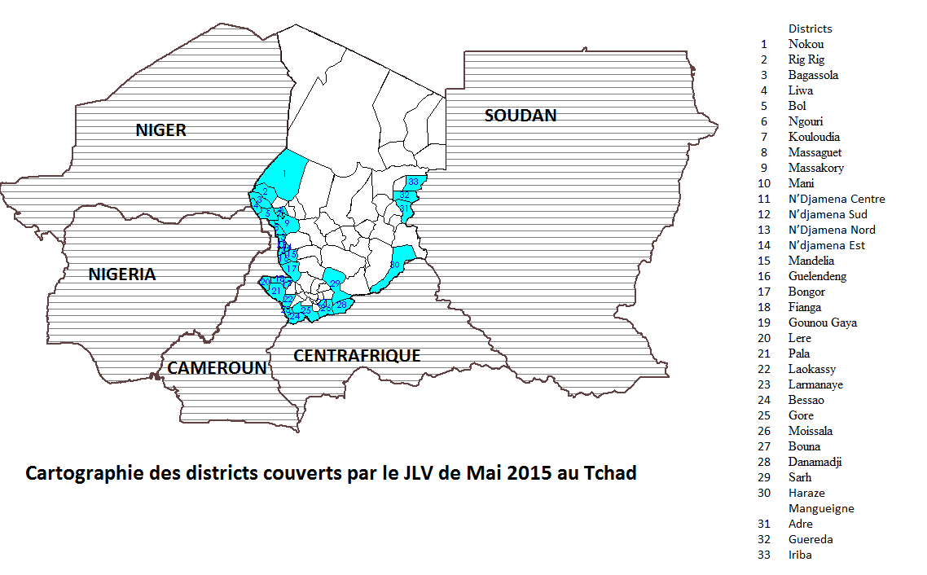
High risk districts bordering CAR, Cameroon, Nigeria and Niger
34
34 Kyabe

A silent zone is an area where no cases of AFP have been reported because the monitoring system is too weak.

